 | YEAR 12 MATHEMATICS SPECIALIST  SEMESTER ONE 2016  TEST 2: Functions

Name: _______________________
Friday 1st April
Time: 50 minutes Mark /45 = %

- Answer all questions neatly in the spaces provided. Show all working.
- You are permitted to use the Formula Sheet in both sections of the test.
- You are permitted one A4 page (one side) of notes in the calculator assumed section.

Calculator free section Suggested time: 30 minutes /28

- [11 marks]

Two functions f and g are defined by and

  - Evaluate

[2]
  - What is the range of when ?

[1]
  - What is the natural domain of

[2]
  - Predict the domain and range for
Domain:
Range:
[2]
  - Determine , including all domain restrictions

for
[2]

Turn over for the last part of question 1

  - Sketch and clearly indicate the range of this composite function. [2]
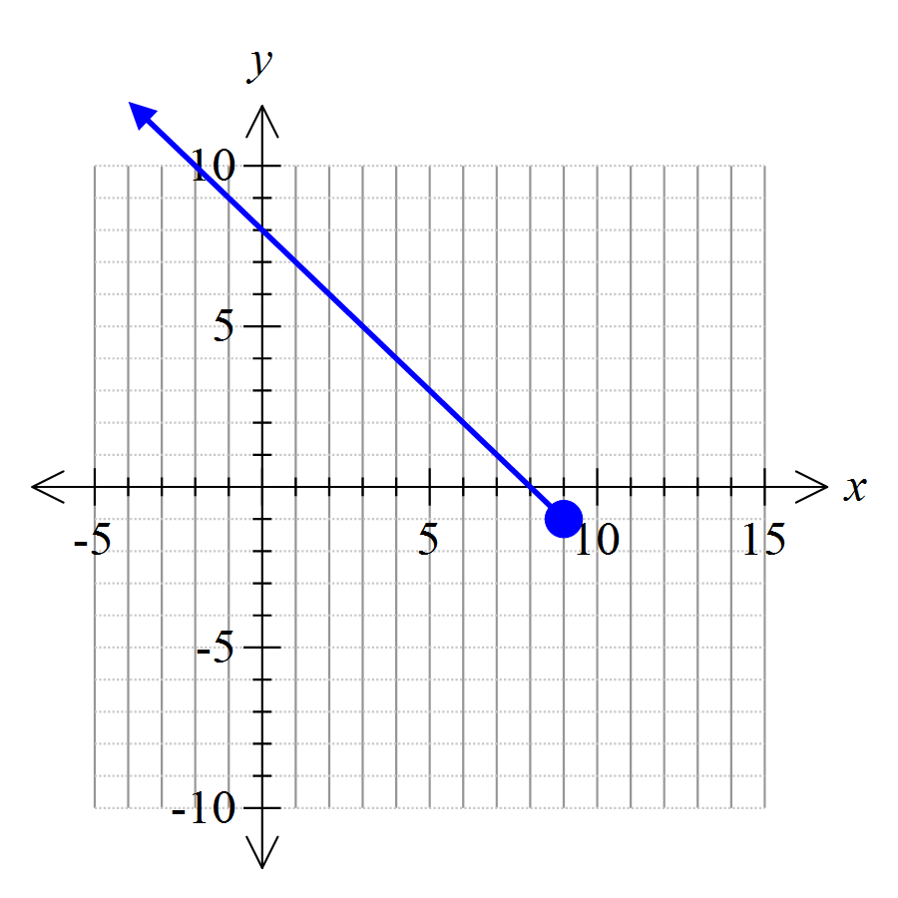

Range:

- [17 marks]

Consider the rational function

  - Identify and classify all points of discontinuity
[4]
provided
Vertical/infinite discontinuity at
(Singular) point discontinuity at

  - List the asymptotes (horizontal and vertical)
[2]
(vertical)
(horizontal, from )

  - Determine all intercepts
[2]
is the only intercept

  - Sketch [3]
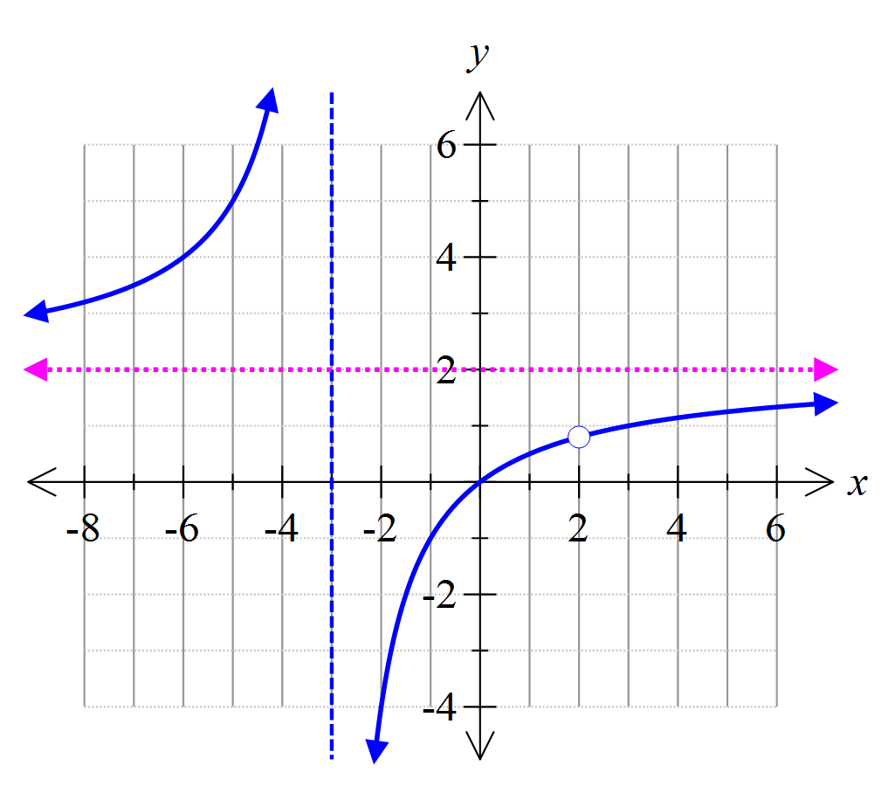
  - Does possess an inverse function ? How do you know?
[2]
Yes; it is a 1 to 1 function over the domain
(passes horizontal line test)

  - Show algebraically that and identify appropriate restrictions on the domain and range.
Use a simplified expression for in your calculations.
[4]
has an inverse defined by
Domain restrictions:
Range restrictions:

Calculator assumed section Suggested time: 20 minutes /17
Name: _______________________
- [5 marks]
Mark solutions to these equations on the number lines provided.
In (b), clearly explain clearly how to use distance considerations in determining the solution.
[1]

Sum of the distance of x from 3 plus distance from 1 should be 4

[3]

[1]

- [5 marks]
The graph of is shown. Add the graphs of and .
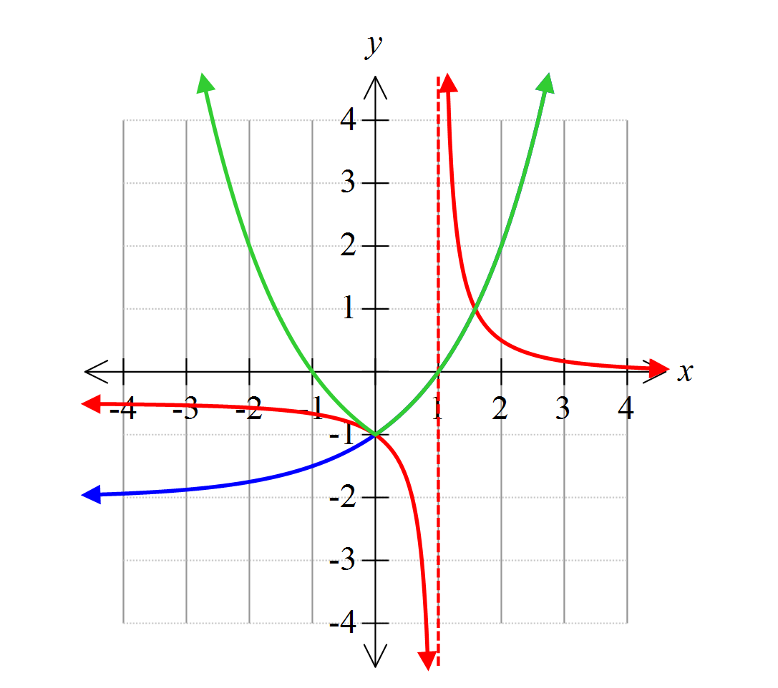

- [7 marks]
This graph represents a function of the form
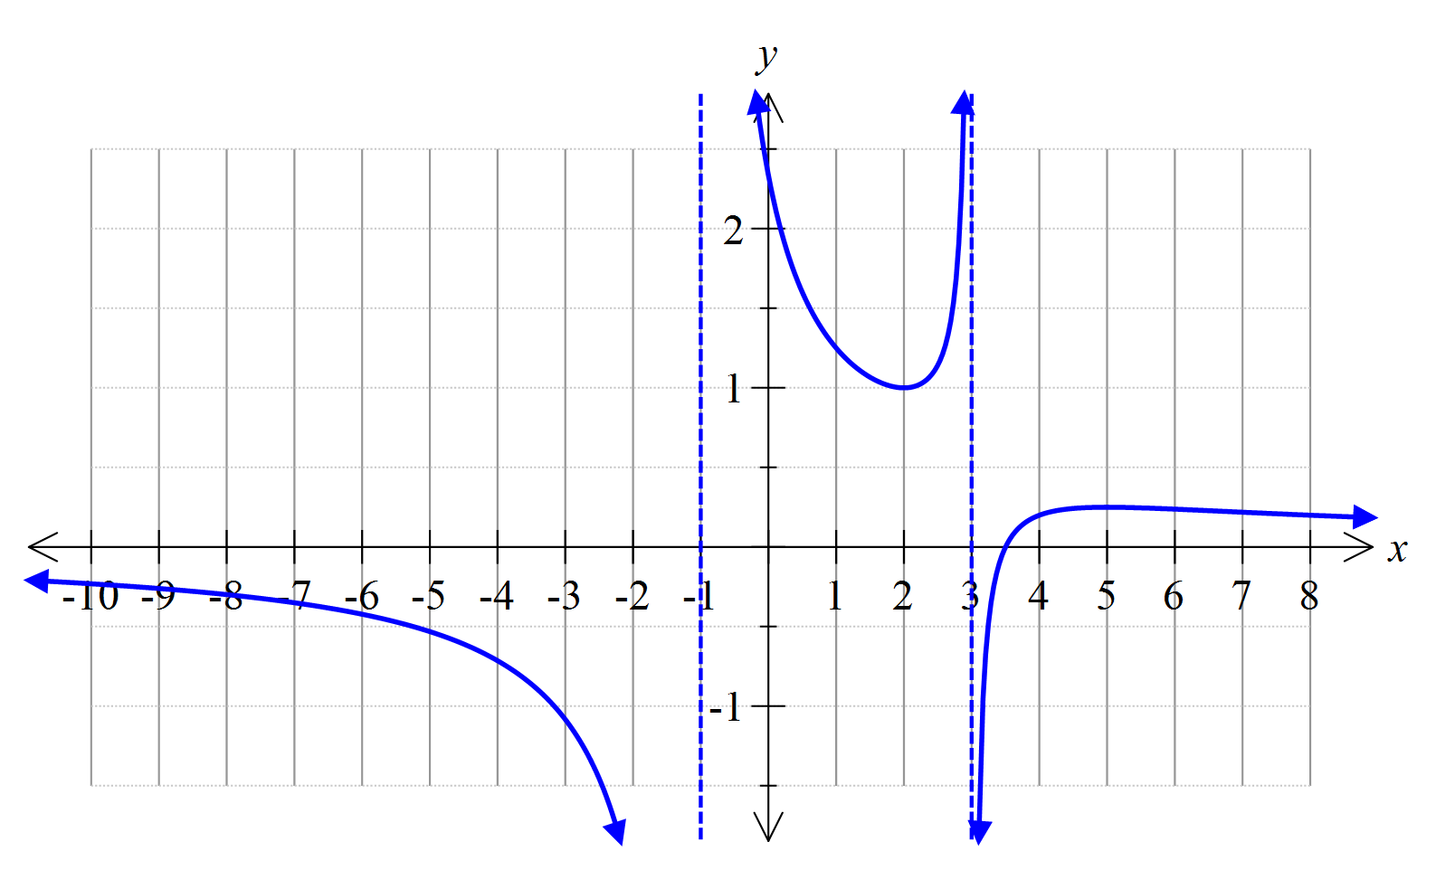
The vertical asymptotes are as shown, the x-intercept is (3.5, 0) and one turning point is at.

        - Determine the values of the constants a, b, c and d.
Vertical asymptotes
Solve simultaneously:
[5]

        - What is the range of ?
Other turning point is
Range is or
[2]

